Streaming App:
- Git Repo Forked:
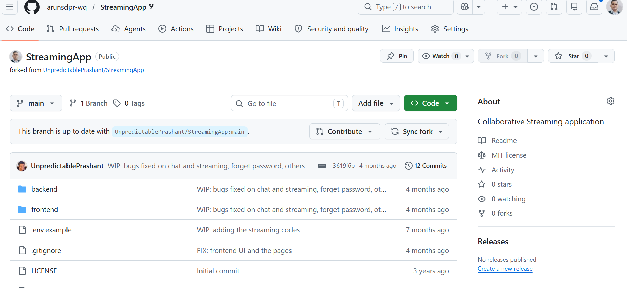
- Amazon ECR
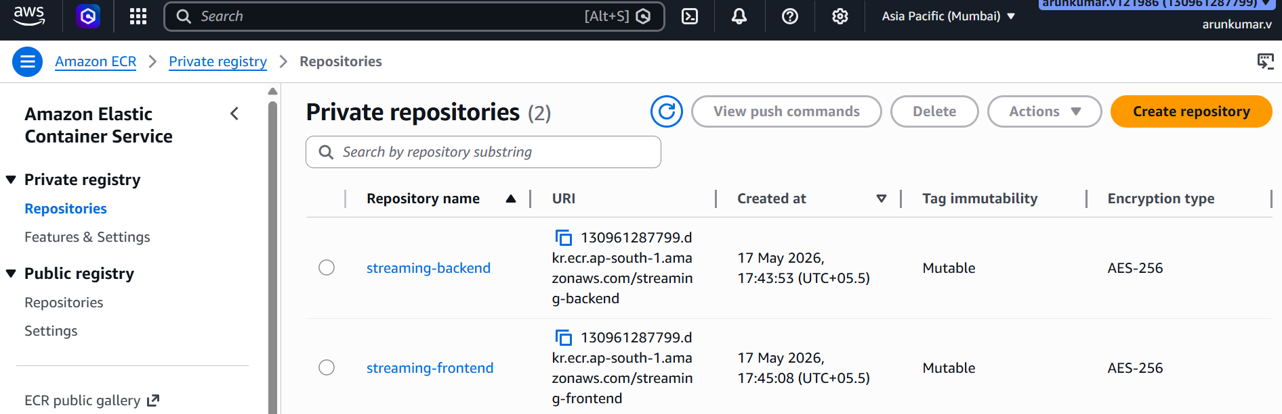
- C:\Users\arunkumar\Documents\Assignments\StreamingApp>docker build -t streaming-backend ./backend
- [+] Building 0.3s (1/1) FINISHED docker:desktop-linux
- => [internal] load build definition from Dockerfile 0.1s
- => => transferring dockerfile: 2B 0.0s
- ERROR: failed to build: failed to solve: failed to read dockerfile: open Dockerfile: no such file or directory

- View build details: docker-desktop://dashboard/build/desktop-linux/desktop-linux/2do08x0pcz8prhocaaf6sfngp
- C:\Users\arunkumar\Documents\Assignments\StreamingApp>docker build -t streaming-frontend ./frontend
- [+] Building 216.7s (16/16) FINISHED docker:desktop-linux
- => [internal] load build definition from Dockerfile 0.0s
- => => transferring dockerfile: 846B 0.0s
- => [internal] load metadata for docker.io/library/nginx:1.27-alpine 3.7s
- => [internal] load metadata for docker.io/library/node:18-alpine 2.1s
- => [auth] library/node:pull token for registry-1.docker.io 0.0s
- => [auth] library/nginx:pull token for registry-1.docker.io 0.0s
- => [internal] load .dockerignore 0.1s
- => => transferring context: 93B 0.0s
- => [build 1/6] FROM docker.io/library/node:18-alpine@sha256:8d6421d663b4c28fd3ebc498332f249011d118945588d0a35cb9bc4b8ca09d9e 0.1s
- => => resolve docker.io/library/node:18-alpine@sha256:8d6421d663b4c28fd3ebc498332f249011d118945588d0a35cb9bc4b8ca09d9e 0.1s
- => [production 1/2] FROM docker.io/library/nginx:1.27-alpine@sha256:65645c7bb6a0661892a8b03b89d0743208a18dd2f3f17a54ef4b76fb8 5.8s
- => => resolve docker.io/library/nginx:1.27-alpine@sha256:65645c7bb6a0661892a8b03b89d0743208a18dd2f3f17a54ef4b76fb8e2f2a10 0.1s
- => => sha256:34a64644b756511a2e217f0508e11d1a572085d66cd6dc9a555a082ad49a3102 1.40kB / 1.40kB 0.7s
- => => sha256:39c2ddfd6010082a4a646e7ca44e95aca9bf3eaebc00f17f7ccc2954004f2a7d 15.52MB / 15.52MB 4.7s
- => => sha256:197eb75867ef4fcecd4724f17b0972ab0489436860a594a9445f8eaff8155053 1.21kB / 1.21kB 1.3s
- => => sha256:81bd8ed7ec6789b0cb7f1b47ee731c522f6dba83201ec73cd6bca1350f582948 402B / 402B 1.4s
- => => sha256:d7e5070240863957ebb0b5a44a5729963c3462666baa2947d00628cb5f2d5773 955B / 955B 0.8s
- => => sha256:61ca4f733c802afd9e05a32f0de0361b6d713b8b53292dc15fb093229f648674 1.79MB / 1.79MB 1.2s
- => => sha256:b464cfdf2a6319875aeb27359ec549790ce14d8214fcb16ef915e4530e5ed235 0B / 629B 211.0s
- => => extracting sha256:61ca4f733c802afd9e05a32f0de0361b6d713b8b53292dc15fb093229f648674 0.4s
- => => extracting sha256:b464cfdf2a6319875aeb27359ec549790ce14d8214fcb16ef915e4530e5ed235 0.0s
- => => extracting sha256:d7e5070240863957ebb0b5a44a5729963c3462666baa2947d00628cb5f2d5773 0.0s
- => => extracting sha256:81bd8ed7ec6789b0cb7f1b47ee731c522f6dba83201ec73cd6bca1350f582948 0.0s
- => => extracting sha256:197eb75867ef4fcecd4724f17b0972ab0489436860a594a9445f8eaff8155053 0.0s
- => => extracting sha256:34a64644b756511a2e217f0508e11d1a572085d66cd6dc9a555a082ad49a3102 0.0s
- => => extracting sha256:39c2ddfd6010082a4a646e7ca44e95aca9bf3eaebc00f17f7ccc2954004f2a7d 0.7s
- => [internal] load build context 0.3s
- => => transferring context: 947.16kB 0.2s
- => CACHED [build 2/6] WORKDIR /app 0.0s
- => [build 3/6] COPY package*.json ./ 0.1s
- => [build 4/6] RUN npm install 82.0s
- => [build 5/6] COPY . . 1.5s
- => [build 6/6] RUN npm run build 124.5s
- => [production 2/2] COPY --from=build /app/build /usr/share/nginx/html 0.2s
- => exporting to image 1.6s
- => => exporting layers 0.7s
- => => exporting manifest sha256:8554dd2ddc0caf1ab411553e1c62928db11b85e5d225b3c8a41f2bc4373d5c6e 0.1s
- => => exporting config sha256:aefb711e5dd5847705d3aaa4e042159ae16169117428ec687caa9c112df12d7e 0.1s
- => => exporting attestation manifest sha256:32c915ffecb41d244fc24af8fae69ce5eb26e9f23023ec3589df8e0966b38815 0.2s
- => => exporting manifest list sha256:e9b6ec6bac3fc663c4d74f8289535e0b6e80a1c225cb97ced5faabafa5834cea 0.1s
- => => naming to docker.io/library/streaming-frontend:latest 0.2s
- => => unpacking to docker.io/library/streaming-frontend:latest 0.2s

- 2 warnings found (use docker --debug to expand):
- - SecretsUsedInArgOrEnv: Do not use ARG or ENV instructions for sensitive data (ARG "REACT_APP_AUTH_API_URL") (line 10)
- - SecretsUsedInArgOrEnv: Do not use ARG or ENV instructions for sensitive data (ENV "REACT_APP_AUTH_API_URL") (line 17)

- View build details: docker-desktop://dashboard/build/desktop-linux/desktop-linux/7ve64kt6fudfq93jfxl77781b

